How to Create Continuous Deployment Pipeline in AWS

**Pre-Requisites**

1) Download and install git on your linux machine

2) Configure git on local machine or ec2 machine

git config --global user.name "Yourname"

git config --global user.email <your emailaaddress>

3) Create new AWS IAM users (or use existing admin user)

Attach IAM policy "ASWScodecommitfullaccess"

Attach IAM policy "AWScodepipelineFullaccess"

4) Create new security credentials

security crdentials -> HTTPS GIT credentials --> Generate and save credentials

5) Create service role for code deploy

create IAM role for codedeploy service

Attach existing IAM policy "AWScodedeployRole"

6) Create IAM role for EC2 to download artifacts from s3

Attach IAM policy "AWSS3ReadOnlyAccess"

**Task 1:**

1. Create repository in Codecommit service.

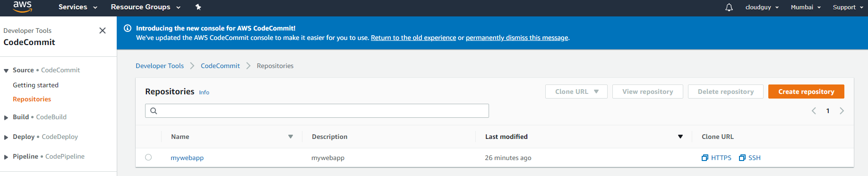

1. Clone this repository on your local machine using git clone command.
2. Download or put your application data on local machine.
3. Now push your app data in codecommit repository using credentials which you saved during IAM user creation.

**Task 2:**

1. Create EC2 machine with Admin access role or any role with AWSS3ReadOnlyAccess permission.
2. Now we need to install the code deploy agent on machine which you can install after machine creation or during machine launching state in user data section.

CODE DEPLOY AGENT INSTALLATION SCRIPT

#!/bin/bash

sudo yum -y update

sudo yum install -y ruby

curl -O <https://bootstrap.pypa.io/get-pip.py>

sudo python get-pip.py

sudo pip install awscli

cd /home/ec2-user

sudo aws s3 cp s3://aws-codedeploy-ap-south-1/latest/install . --region ap-south-1

sudo chmod +x ./install

sudo ./install auto

**Task 3:**

1. Open Code Deploy service in AWS account
2. Click on Create application and give the name of application.

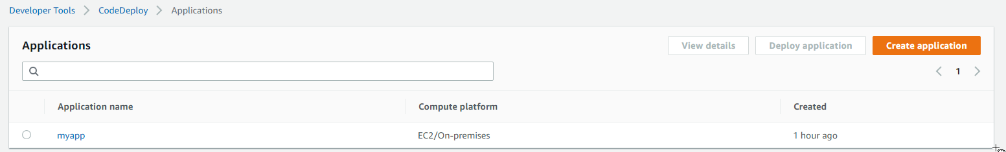

1. Now need to create deployment group.

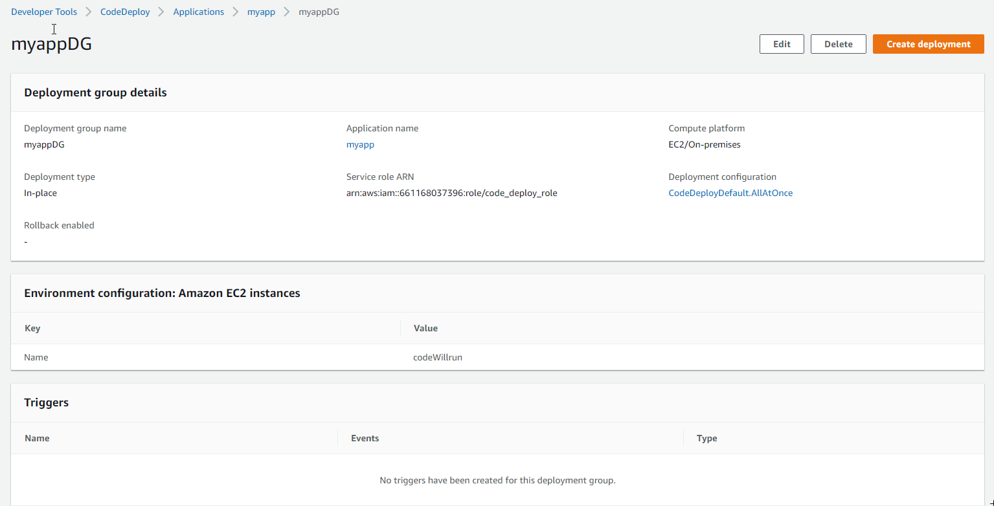

**Task 4:**

1. Open codepipeline service in AWS account.
2. Create pipeline and fill the required info like app name and deployment group name.

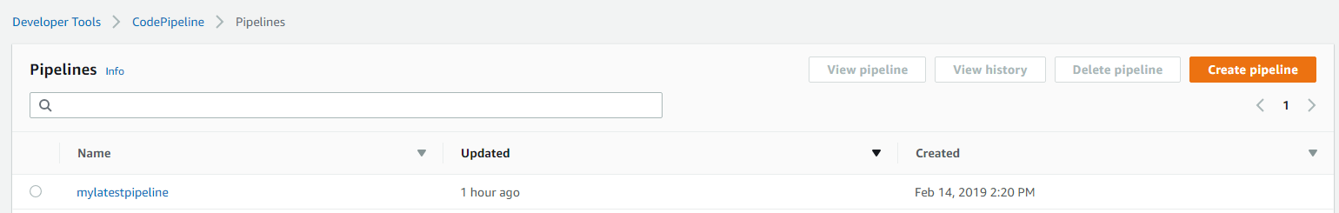

1. Now click on create pipeline and your code will start to deploy.

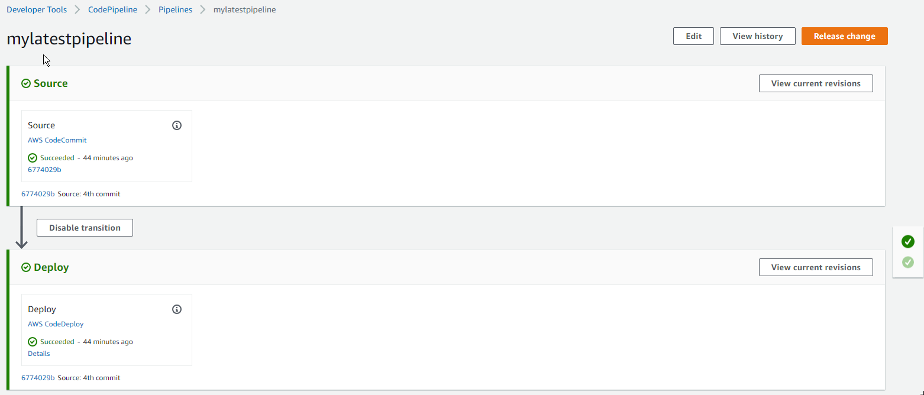

Here All your tasks done successfully.

Suppose you have made changes in the code then you will have to push that in the codecommit repository.

Pipeline will automatically take care or your changes and will reflect on the application.

**HAPPY LEARNING**